Introduction
Playwright is an open source automation testing framework .it test end to end test for modern web , mobile applications in headless or headed mode in a different platform with single API is known as Playwright
Advantages
- It is free and Open Source automation framework
- It supports multiple Browsers like chromium , firefox, webkit , Microsoft Edge etc
- It supports multiple Os like Windows , mac , linux etc
- It contains AutoWait features to wait automatically before performing actions on elements based on clickable , enable , visible to avoid Flaky Tests.
- Contains powerful built in tools like Trace viewer for Debugging and codegen to record actions in real time and generate scripts
- It provide easy network controlling like interception , modifications , mocking of network request and Websockets
- It contains Mobile Emulator to test Mobile Web Applications
- It generates HTML reports automatically .
- It has a Configuration to perform parallel Execution and Cross Browser testing
Disadvantages
- It has smaller community support
- No legacy browser support such as internet explorer 11
- No Native Mobile App Support
- To learn playwright one programming language is mandatory which can pose a challenge for Non-technical QA teams

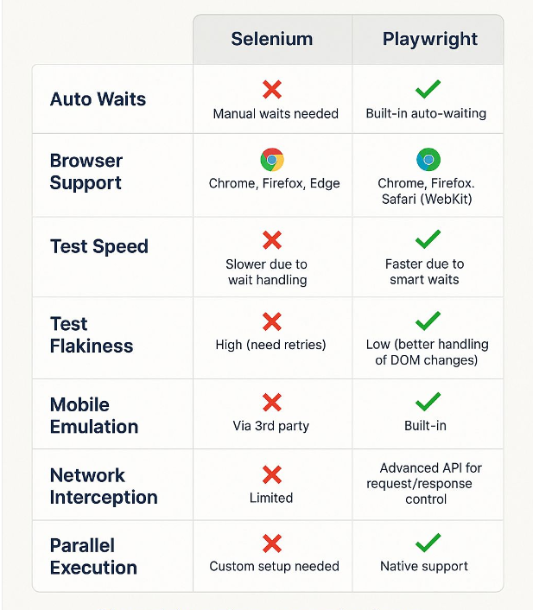

How to Create TestScripe
To create test script we are following one syntax

import { test, expect } from '@playwright/test';

test('has title', async ({ page }) => {
await page.goto('https://playwright.dev/');

// Expect a title "to contain" a substring.
await expect(page).toHaveTitle(/Playwright/);
});

Run test scripts commands

Command | Description
npx playwright test | Runs all tests on all browsers in headless mode.
npx playwright test --headed | Runs all tests in headed (non-headless) mode.
npx playwright show-report | Opens the HTML test report.
npx playwright test MyTest1.spec.ts | Runs a specific test file.
npx playwright test --project=chromium --headed FirstTest.spec.ts | Runs a specific test file only on Chromium in headed mode.
npx playwright test MyTest1.spec.ts MyTest2.spec.ts | Runs multiple specified test files.
npx playwright test -g "test title" | Runs the test(s) that match the given title.
npx playwright test --project=chromium | Runs all tests on the Chromium browser only.
npx playwright test --debug | Runs tests in debug mode.
npx playwright test example.spec.ts --debug | Debugs a specific test file.

npx playwright test --ui Run in UI mode

npx playwright test --last-failed Run last failed test Script

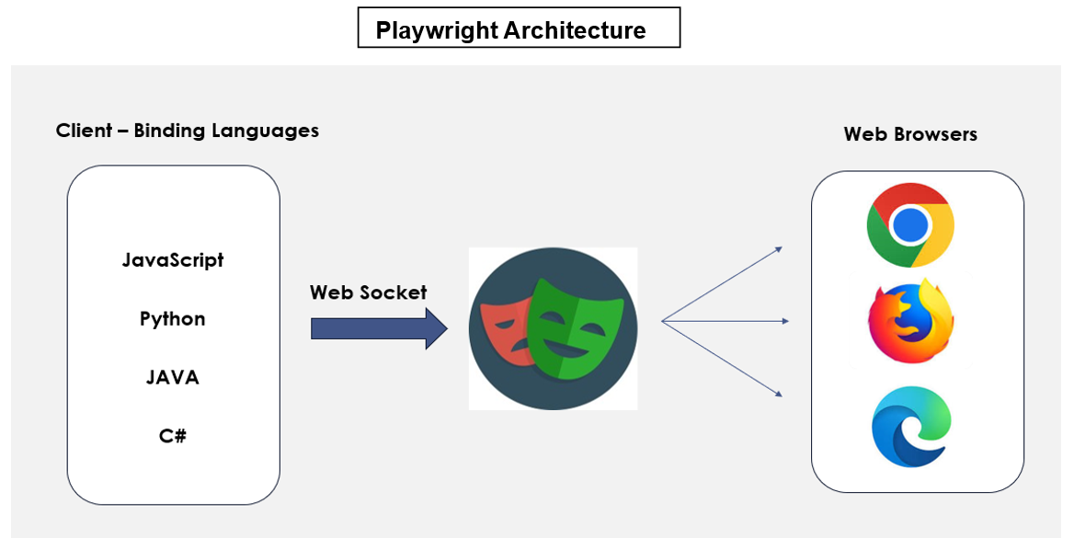

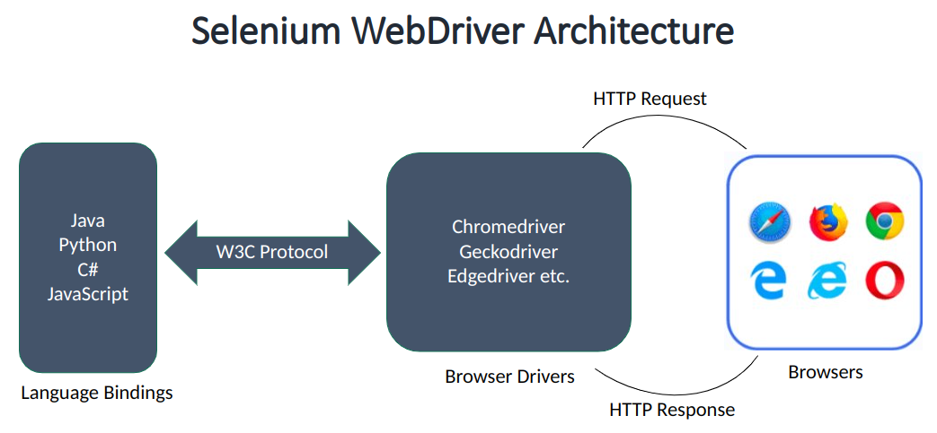

Different between HTTP and Websocket connection

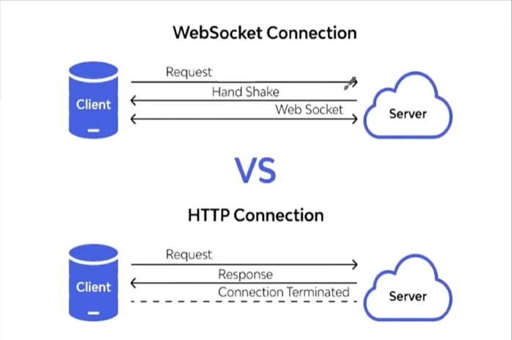

What is a WebElement in a Webpage?
A WebElement is any individual element present on a webpage, such as text, links, buttons, images, text boxes, checkboxes, radio buttons, dropdowns, etc.
- These elements are created using web technologies such as HTML (structure), CSS (styling), and JavaScript (behavior and interactivity).
- The source code of a webpage can be viewed in the HTML DOM (Document Object Model).
- The HTML DOM is a tree-like representation of all the HTML elements on a webpage. It organizes elements in a hierarchical structure, making it easier to identify and access them.
- The DOM allows programming languages like JavaScript to interact with webpage elements by accessing, modifying, updating, adding, or removing elements and their content dynamically.

How to Open the HTML DOM (Developer Tools)
There are multiple ways to open the HTML DOM in a browser.

Method 1: Right Click → Inspect (Most Common)
- Open the webpage.
- Right-click on any element.
- Click Inspect.
- The browser opens Developer Tools with the selected HTML element highlighted.

Method 2: Keyboard Shortcut
Press:
- F12 → Opens Developer Tools.
- Ctrl + Shift + I (Windows/Linux)
- Cmd + Option + I (Mac)

How to Perform Actions on WebElements in Playwright
Playwright uses a Locator to identify and interact with elements on a webpage. A Locator represents a web element and also provides methods to perform various actions. Like click ,enter text,Clear Existing Text ,Hover Over etc

How to Locate Elements in a Webpage?
To interact with any element on a webpage, Playwright must first locate that element. Playwright provides different types of locators to identify web elements accurately.
Locators in Playwright can be broadly classified into two categories:

1. Playwright Built-in Locators (Recommended)
These are the locators provided by Playwright. They are more reliable because they are based on how users interact with the application and support auto-waiting.
Examples:

- getByAltText() – Locates an image or element using its alt (alternative) text.
- getByText() – Locates an element using its visible text.
- getByLabel() – Locates a form element associated with a label.
- getByPlaceholder() – Locates an input field using its placeholder text.
- getByTitle() – Locates an element using its title attribute.
- getByTestId() – Locates an element using its test ID attribute (commonly data-testid).
- getByRole() – Locates an element based on its accessible role (button, textbox, link, checkbox, etc.).

Playwright Locator Methods

Method | Simple Explanation
click() | Clicks on an element.
dblclick() | Double-clicks an element.
hover() | Moves the mouse over an element.
fill() | Clears the input and enters new text.
clear() | Removes all text from an input field.
press() | Presses a keyboard key (e.g., Enter, Tab).
pressSequentially() | Types text one character at a time.
focus() | Places the cursor inside an element.
blur() | Removes focus from an element.
check() | Checks a checkbox or radio button.
uncheck() | Unchecks a checkbox.
setChecked() | Sets a checkbox to checked or unchecked.
selectOption() | Selects an option from a dropdown.
selectText() | Selects the text inside an element.
setInputFiles() | Uploads one or more files.
dragTo() | Drags one element and drops it onto another.
tap() | Simulates a tap on touch devices.
scrollIntoViewIfNeeded() | Scrolls the element into view if needed.
dispatchEvent() | Triggers a DOM event (like click or change).
waitFor() | Waits for the element to reach a specified state.
textContent() | Returns the text content of the element.
innerText() | Returns the visible text of the element.
innerHTML() | Returns the HTML inside the element.
inputValue() | Returns the value of an input field.
getAttribute() | Returns the value of a specified attribute.
allTextContents() | Returns text from all matching elements.
allInnerTexts() | Returns visible text from all matching elements.
count() | Returns the number of matching elements.
boundingBox() | Returns the position and size of the element.
isVisible() | Checks if the element is visible.
isHidden() | Checks if the element is hidden.
isEnabled() | Checks if the element is enabled.
isDisabled() | Checks if the element is disabled.
isEditable() | Checks if the element can be edited.
isChecked() | Checks if a checkbox or radio button is selected.
screenshot() | Takes a screenshot of the element.
evaluate() | Runs JavaScript on the element.
locator() | Finds a child element inside another element.
filter() | Filters matching elements based on conditions.
first() | Returns the first matching element.
last() | Returns the last matching element.
nth(index) | Returns the element at the specified index.
and() | Matches elements that satisfy two locators.
or() | Matches elements that satisfy either of two locators.
all() | Returns all matching locators as an array.

